RAG Postgres Schema Design
Oct 21, 2026 · @Mahesh

Summary
Use four tables, one per pipeline stage, so each stage can be rebuilt without redoing the one before it. Retrieval reads only the last table.
# | Table | One row per | Holds
1 | documents | Source item: a PDF file, a Confluence page, an Excel sheet | Where it came from, its version, a content hash, who may see it
2 | document_contents | Extracted element: page, heading, issue, error, paragraph, table, row, image | The document's structure in reading order, with page or row location
3 | chunks | Retrieval unit built from contents | Chunk text, path label, type, parent link, lineage back to contents
4 | retrieval_index | Chunk × embedding model | The vector, the full-text index and a copy of every filter field
What this buys us:
- Re-chunk without re-parsing. Contents are kept, so a new chunking strategy reruns from table 2 only.
- Re-embed without re-chunking. Each model has its own rows in table 4, so experiment variants and model upgrades sit side by side.
- Incremental sync. A content hash at each stage skips anything unchanged.
- Fast, simple retrieval. Vector search, keyword search and filters run on one table with no joins.
- Citations and access control. Every result traces back to its file, page, section and link, every ingestion and question is logged, and row-level security limits what each user can retrieve.

Review status
We are finalizing the design one stage at a time; Stage 1 (source and extraction) is final.
Table | Stage | Status | Notes
documents | 1 · Source and extraction | Final | Source registry, links, ownership, access
document_versions | 1 · Source and extraction | Final | Every version, stored original, extraction checks
document_contents | 1 · Source and extraction | Final | Every page, text element and image, with links
chunks | 2 · Chunking | Next | Add image and page-image chunks
retrieval_index | 3 · Search | To review
Audit tables | Audit | To review | ingestion_runs, ingestion_events, retrieval_logs, retrieval_hits

Architecture at a glance
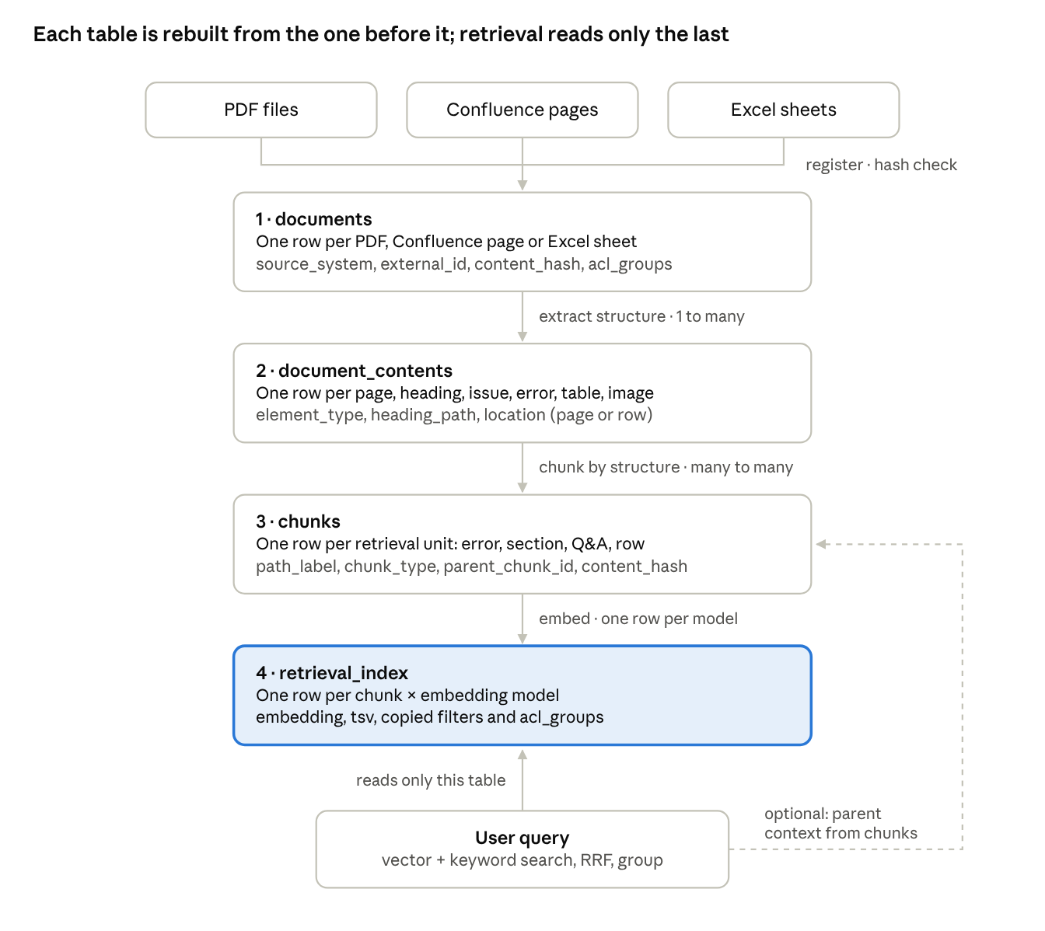
four-table pipeline · 3 sources, 4 tables, 1 query path
A new chunking strategy reruns from table 3; a new embedding model reruns table 4 only. Queries never join back unless they want a chunk's parent for extra context.

How the tables connect
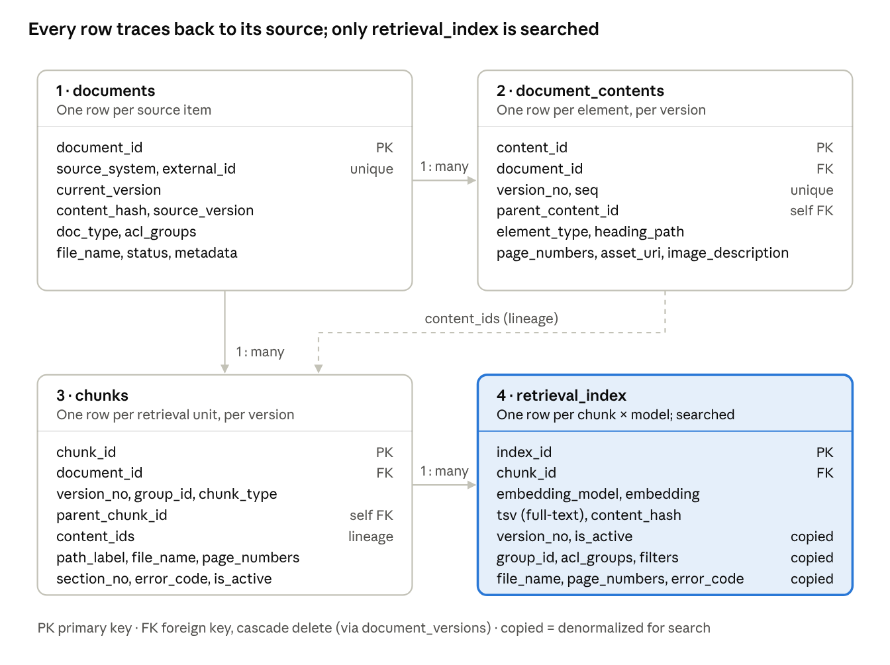
schema · 4 tables, 3 foreign keys, 1 lineage link
documents owns everything below it: deleting a document cascades to its contents, chunks and index rows. Chunks point back to the contents they were built from through content_ids, so every search result can be traced to a page, anchor or row.

One document through the four tables
Follow one 3-page FAQ PDF, “How do I upload files?”, from file to searchable rows. It has an Upload heading, one issue and three errors.
Table 1 · documents: what we ingested. One row, whatever the size of the file.
document_id | source_system | file_name | doc_type | current_version | content_hash | acl_groups | status
d-12 | pdf | faq-12.pdf | faq | 1 | 9f3a… | {support} | active
Table 2 · document_contents: what the parser found. One row per element, in reading order, with its place in the heading tree and its page.
seq | element_type | section_no | heading_path | text | page_numbers
0 | faq_question | — | — | How do I upload files? | {1}
1 | heading | 2 | Upload | Upload | {1}
2 | issue | 2.1 | Upload | Upload fails with an error code | {1}
3 | error | 2.2 | Upload › Issue resolution | Error 1: network timeout. Retry on a stable connection. | {2}
4 | error | 2.3 | Upload › Issue resolution | Error 2: file too large. Keep files under 25 MB. | {2,3}
5 | error | 2.4 | Upload › Issue resolution | Error 3: unsupported type. Use PDF or DOCX. | {3}
Alongside these sit three page rows (full text and a rendered image of pages 1–3) and one image row for the upload-error screenshot on page 2, linked to the Error 2 row (see What one page becomes).
Table 3 · chunks: what we decided to retrieve. Every row also carries file_name = faq-12.pdf, group_id = FAQ-12 and version_no = 1. page_numbers is the union of the pages of the contents listed in content_ids.
chunk_type | path_label | chunk_text | section_no | error_code | page_numbers | content_ids
question | How do I upload files? | How do I upload files? | — | — | {1} | {0}
paraphrase | How do I upload files? | why can't I upload my document | — | — | {1} | {0}
overview | … › Upload | Upload fails with an error code. Errors 1–3: timeout, too large, unsupported type | 2 | — | {1} | {1, 2}
error_chunk | … › Issue resolution › Error 1 | Error 1: network timeout. Retry on a stable connection. | 2.2 | Error 1 | {2} | {3}
error_chunk | … › Issue resolution › Error 2 | Error 2: file too large. Keep files under 25 MB. | 2.3 | Error 2 | {2,3} | {4}
error_chunk | … › Issue resolution › Error 3 | Error 3: unsupported type. Use PDF or DOCX. | 2.4 | Error 3 | {3} | {5}
Table 4 · retrieval_index: what search reads. One row per chunk per embedding model, with the filters copied in. The Error 2 row looks like this:
chunk | embedding_model | version_no | is_active | file_name | page_numbers | section_no | error_code | acl_groups | embedding
Error 2 chunk | gemini-embedding-2@768 | 1 | true | faq-12.pdf | {2,3} | 2.3 | Error 2 | {support} | [0.012, −0.044, …] (768 numbers)
Embedding the same chunks with a second model adds a second set of rows; tables 1–3 don't change.
Other sources fill the same tables:
- Confluence page: one documents row per page (external_id = page id, source_version = page version), heading sections in document_contents with anchors as location, and one chunk per section.
- Excel sheet: one documents row per sheet, one table_row element per row with the cells stored in raw (for example {"Error code": "E2", "Fix": "Keep files under 25 MB"}), and one chunk per row written as “Error code: E2 / Fix: Keep files under 25 MB”.

When a document changes
The same document keeps its document_id; each version gets its own rows with a version_no, and search reads only rows where is_active is true. Users never see a mix of old and new answers, and unchanged sections are not re-embedded.
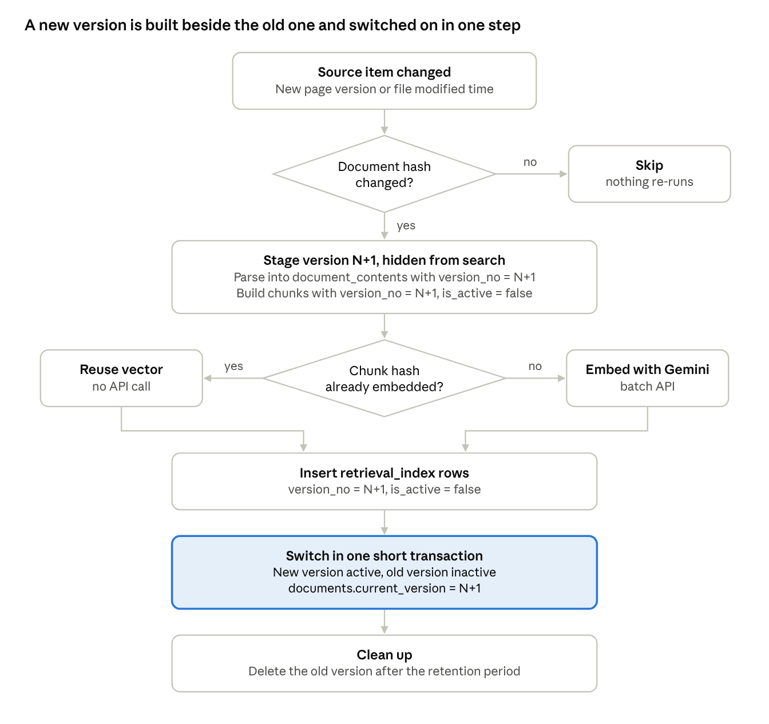
version update flow · 2 hash checks, 1 switch
Example: v1 → v2 of the upload FAQ. Error 2's limit changes from 25 MB to 50 MB, Error 3 is removed and Error 4 is added.
Table | What happens
documents | Same row. content_hash and source_version update; current_version goes from 1 to 2 at the switch
document_contents | A new set of rows with version_no = 2; the v1 rows stay until clean-up
chunks | A new set with version_no = 2: question, paraphrases, overview and Error 1 unchanged; Error 2 changed; Error 4 new; Error 3 absent
retrieval_index | Unchanged chunks copy their stored vector by content_hash; only Error 2, Error 4 and the edited overview call Gemini. The switch makes v2 active and v1 inactive
In a test on PostgreSQL 16 with three error chunks, the v2 rows stayed invisible until the switch; the unchanged Error 1 reused its stored vector, and only the changed Error 2 and the new Error 4 were embedded.
Rules
- Same document, new version = same document_id, new version_no. A new file or page id = a new document.
- What counts as a version: Confluence page version number; for files, the modified time plus content hash; for Excel, the hash of each sheet.
- Keep the switch short. Never hold a transaction open while calling the embedding API: stage the rows hidden first, then switch in one quick transaction.
- Retention: keep the previous version for a set period (for example 30 days) for rollback and audit, then delete its chunks and contents; index rows go with the chunks by cascade.
- Rollback = run the switch again with the old version number.
- Permission change only: update acl_groups on documents and copy it to the index rows; nothing is re-parsed or re-embedded.
- Deleted at the source: mark status = 'deleted', then delete the documents row; cascades remove everything under it.
This matches how common indexing tools sync: the LangChain indexing API skips documents whose hash is unchanged and cleans up rows from changed or deleted sources, and LlamaIndex re-processes a document only when its hash changes.

Traceability, audit and monitoring
Any answer can be traced to the exact page, section or row it came from, the document version, a stored copy of the original, and the pipeline run that built it. Every ingestion and every question is logged. Five audit tables sit beside the four core tables: document_versions, ingestion_runs, ingestion_events, retrieval_logs and retrieval_hits.

Trace-back chain
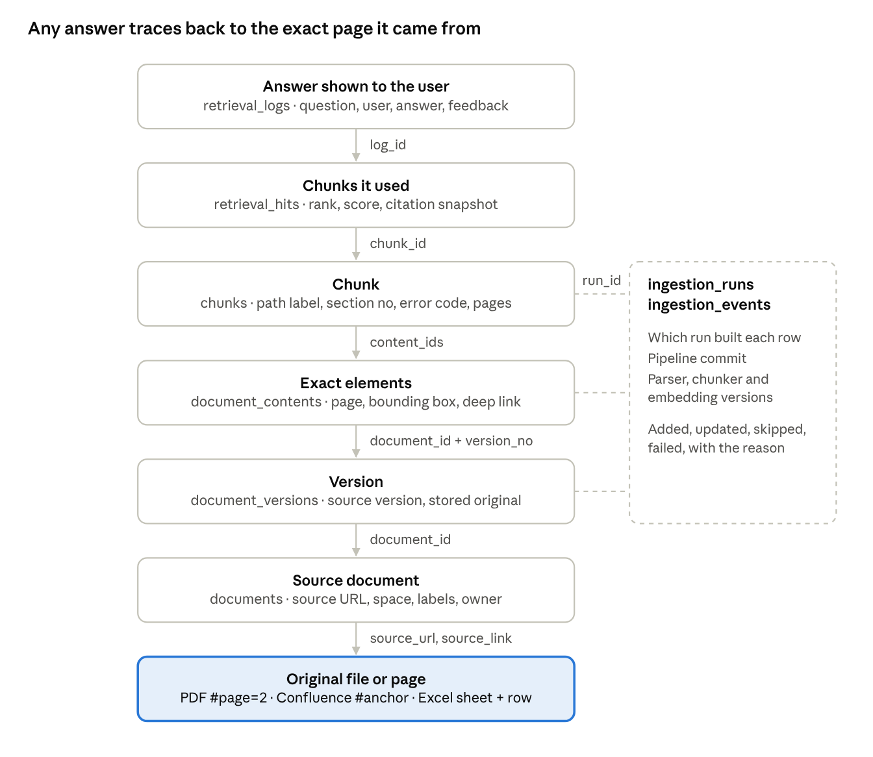
trace-back chain · 7 steps, join key on each link
Each step is one join on the key shown, so a support person can go from a complaint about an answer to the exact page, version and pipeline run in a single query (Appendix).

Lineage fields in every table
Table | Lineage fields | Answers
retrieval_hits | log_id, rank, chunk_id, version_no, content_hash, plus a snapshot of file_name, page_numbers, section_no, error_code, source_link | Which chunks this answer used and where they came from, even after a purge
retrieval_index | chunk_id, document_id, version_no, run_id, source_url, source_link | Which chunk and version a search hit is
chunks | content_ids, page_numbers, section_no, error_code, tags, source_link, chunker_version, run_id | Which elements, pages and section built the chunk, and which run and chunker made it
document_contents | page_numbers, coordinates, location, source_link, parser_version, run_id | The exact page, position on the page, anchor or row
document_versions | source_version, content_hash, raw_snapshot_uri, source_url, run_id, activation times | Which version of the source, with a stored copy of the original as it was
documents | source_url, source_uri, external_id, source_container, tags, author, last_modified_by | Where the document lives, which space or folder, its labels and owner
ingestion_runs, ingestion_events | pipeline_version, parser, chunker and model versions, action, reason | How and when each row was built, or why a document was skipped or failed
Parsing libraries already emit most of these fields: Unstructured attaches filename, page_number, bounding-box coordinates, parent_id and last_modified to every element.

Source links by source type
Source | source_url (document) | source_link (exact place, per chunk) | Also stored
PDF | Link to the file (SharePoint, Drive, file share, bucket) | File link + #page=2, the standard PDF page fragment (RFC 8118) | file_name, page_numbers, section_no, bounding box
Confluence | The page's web link | Page link + #heading-anchor | Page id, space (source_container), page version, labels (tags), author
Excel | Workbook link | Workbook link + sheet and row, shown as “errors.xlsx · Sheet1 · row 14” | Sheet name, row number, column headers in raw

Audit tables
Table | One row per | Key columns
document_versions | Version of a document | source_version, content_hash, raw_snapshot_uri, status (staged → active → superseded → purged), run_id
ingestion_runs | Pipeline run | pipeline_version (git commit), parser, chunker and embedding versions, triggered_by, status, counts of added, updated, skipped, failed, embedded and reused
ingestion_events | Document in a run | action (added, updated, skipped, deleted, failed, acl_changed), reason, chunks embedded and reused
retrieval_logs | Question asked | User and groups, query, filters, model and chunker versions, route, top score, answer, latency, feedback
retrieval_hits | Chunk retrieved for a question | Rank, scores, used_in_answer, version, content hash, citation snapshot
Retention. Chunks and contents of old versions can be purged to keep search lean. document_versions rows, the stored original in object storage (raw_snapshot_uri), ingestion events and retrieval logs are kept, so an old answer still traces to the exact source it came from. Questions and user ids are personal data: give retrieval_logs its own retention period and a restricted role.

What to monitor
Signal | From | Watch for
Failed or missed runs | ingestion_runs.status, started_at | Any failure; a scheduled run that didn't happen
Documents that failed to parse | ingestion_events where action = 'failed' | The same document failing twice
Stale sources | documents.source_updated_at vs. latest document_versions.ingested_at | Source changed but not re-ingested within the agreed time
Documents with no chunks | documents without active chunks | Parser found nothing usable
Re-embedding volume | ingestion_runs.chunks_embedded vs. chunks_reused | Spikes in cost or unexpected churn
Hand-off rate | retrieval_logs.route = 'handoff' | A rising rate means a coverage gap
Unanswered topics | retrieval_logs with low top_score | Recurring questions that need a new FAQ
Negative feedback | retrieval_logs.feedback = -1 joined to retrieval_hits | Which chunk or document misled the answer
Never-retrieved chunks | retrieval_index rows absent from retrieval_hits for 90 days | Dead content or poor chunking
Latency | retrieval_logs.latency_ms, p95 | Regressions after index or model changes
Tested on PostgreSQL 16: a logged answer traced to its Confluence page anchor, page version, stored original and pipeline run, and the same trace still returned the citation and stored original after the cited version's chunks were purged.

Table design
Each table keeps the keys and hashes it needs to rebuild itself from the table before it; table 4 also copies the fields retrieval filters on.

Table 1: documents (final)
One row per source item: a PDF file, a Confluence page or an Excel sheet. It records what the item is, where it lives, who owns it and who may see it; details of each version live in document_versions. Unique on (source_system, external_id).
Column | Type | Required | Purpose | Example
document_id | uuid, PK | yes | Internal id | d-12
source_system | text | yes | Where it comes from | pdf, confluence, excel
external_id | text | yes | Id in the source; unique together with source_system | faq/faq-12.pdf, Confluence page 48213
source_url | text | yes | Clickable link to the file or page | https://files.example.com/faq/faq-12.pdf
source_uri | text | no | Machine location the connector reads | gs://inbox/faq-12.pdf
source_container | text | no | Confluence space, SharePoint site or folder | SUP
file_name | text | yes | Shown in every citation | faq-12.pdf
title | text | no | Document or page title | How do I upload files?
mime_type | text | yes | File type; picks the parser | application/pdf
doc_type | text | yes | Picks the chunking strategy | faq
tags | text[] | no | Confluence labels or file tags | {upload, support-faq}
language | text | yes | Full-text configuration and filters | english
metadata | jsonb | no | Any other source-specific field | {"space_key": "SUP"}
author, last_modified_by | text | no | Who wrote and last edited it | j.doe
owner_team | text | no | Who answers questions about the content | Support Ops
acl_groups | text[] | yes | Groups allowed to retrieve it | {support}
current_version | int | no | Version search serves; empty until the first version is switched on | 2
content_hash | text | yes | Hash of the latest content; unchanged means skip | 9f3a…
status | text | yes | active or deleted | active
source_created_at, source_updated_at | timestamptz | no | Dates reported by the source | 2026-10-02
first_ingested_at, last_ingested_at | timestamptz | first: yes | When we first and last ingested it | 2026-10-21
last_run_id | bigint, FK | no | Pipeline run that last touched it | 418

Table 1a: document_versions (final)
One row per version ever ingested. It is kept after that version's chunks are purged, so old answers stay traceable. Primary key (document_id, version_no).
Column | Type | Required | Purpose | Example
document_id, version_no | PK, FK | yes | Which document and which version | d-12, 2
source_version | text | no | Version as the source names it | Confluence version 17; file modified 2026-10-02
content_hash | text | yes | Hash of this version's content | 7b21…
raw_snapshot_uri | text | yes | Stored copy of the original file or page export | gs://rag-raw/pdf/d-12/v2/original.pdf
source_url | text | yes | Link as it was for this version | https://files.example.com/faq/faq-12.pdf
mime_type, file_size_bytes | text, bigint | type: yes | File type and size | application/pdf, 812,400
page_count, image_count, ocr_page_count | int | no | Pages, extracted images, pages that needed OCR | 3, 1, 0
extraction_status | text | yes | pending, extracted, partial, failed | extracted
extraction_coverage | numeric | no | Share of page text captured in elements, 0–1 | 0.98
status | text | yes | staged → active → superseded → purged | active
run_id | bigint, FK | yes | Run that ingested it | 418
ingested_at, activated_at, superseded_at | timestamptz | ingested: yes | Lifecycle times | 2026-10-21

Table 2: document_contents (final)
Everything extracted from a version, in three kinds of rows. A page row per page holds the page's full text and a rendered image, so nothing on a page is lost even if the layout parser misses it. A row per text element holds headings, issues, errors, paragraphs, lists, tables and table rows. An image row per figure or screenshot holds the cropped image, its caption, a generated description and any text inside it. Unique on (document_id, version_no, seq), with exactly one page row per page.
Column | Type | Rows | Purpose | Example
content_id | uuid, PK | all | Internal id | c-41
document_id, version_no | FK | all | Document version it belongs to (cascade delete) | d-12, 2
parent_content_id | uuid, FK (self) | text, image | The heading it sits under; an image points to the error it illustrates | the Error 2 row
seq | int | all | Reading order | 7
element_type | text | all | page, heading, issue, resolution, error, paragraph, list, table, table_row, image, faq_question, faq_answer, other | image
level, heading_path, section_no | int, text[], text | text, image | Heading depth, headings above, number printed on the heading | 3; {Upload, Issue resolution}; 2.3
page_no, page_numbers | int, int[] | all | Start page, and every page covered (physical pages, first = 1) | 2; {2,3}
page_label | text | all | Page number as printed, when it differs | iv
text | text | all | Page: full page text. Text element: its text. Image: its caption | Error 2: file too large…
raw | jsonb | table, table_row | Original markup, or cells with their column headers | {"Error code": "E2", "Fix": "…"}
coordinates | jsonb | text, image | Bounding box on the page, for highlighting | 4 corner points, pixel space
location | jsonb | all | Confluence anchor, Excel sheet and row | {"anchor": "error-2"}
source_link | text | all | Deep link to the exact place | faq-12.pdf#page=2
links | jsonb | all | Links inside the element, with their text | [{"url": "https://intranet/size-policy", "text": "size policy"}]
asset_uri | text | page, image | Our stored image: page render or cropped figure | gs://rag-assets/d-12/v2/img-0002-01.png
asset_source_url | text | image | Original image URL, e.g. a Confluence attachment | …/download/attachments/48213/dialog.png
asset_mime, asset_hash, width_px, height_px | text, text, int, int | page, image | Image type, hash (spots repeated logos), size | image/png; a1b2…; 468 × 210
ocr_text, ocr_confidence | text, real | page, image | Text read from a scanned page or inside an image | “File exceeds 25 MB · Retry”; 0.97
caption | text | image | Caption printed in the document | Figure 4: upload error dialog
image_description, description_model | text | image | Vision-model description, always labelled as generated, and the model that wrote it | “Upload dialog with a red banner reading File exceeds 25 MB…”; gemini flash
extraction_method | text | all | native, ocr, vision_llm, api | vision_llm
content_hash | text | all | Change detection per element | e2c9…
parser, parser_version, run_id | text, text, bigint | all | What produced the row, and in which run | pdf-layout, p2, 418
Page rows apply to paginated files (PDF, Word, PowerPoint). Confluence pages and Excel sheets have no pages; they skip page rows and use location and source_link instead.

What one page becomes
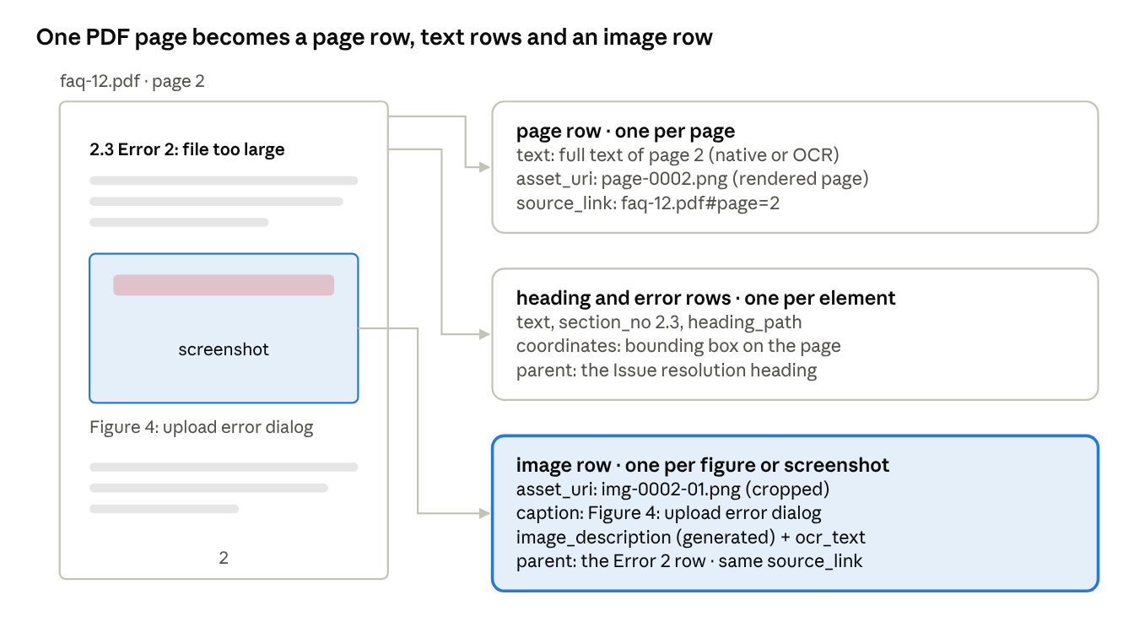
one page · 1 page row, text rows, 1 image row
The screenshot is tied to Error 2 through parent_content_id, so its description and in-image text travel with that error's chunk.

Extraction steps
- Snapshot. Copy the original file or page export to object storage; record raw_snapshot_uri, size and hash in document_versions.
- Pages. Render each page to an image and read its native text. Pages with almost no text layer are scanned, so run OCR on them. Write one page row per page.
- Layout. Detect headings, issues, resolutions, errors, paragraphs, lists and tables, each with its page and bounding box. Set heading_path, section_no and parent_content_id.
- Tables. Keep cells with their column headers in raw; each Excel row becomes a table_row.
- Images. Crop each figure or screenshot, store it, and record caption, size and hash. Skip decorative images: very small ones and any image whose hash repeats on most pages (logos, headers).
- Describe images. A vision model writes image_description and reads ocr_text; link each image to the heading or error it sits under.
- Links. Build source_link for every row (#page=N, #anchor, sheet and row) and asset_source_url for Confluence attachments.
- Check and record. Run the completeness checks below, set extraction_status and extraction_coverage, and log the result to ingestion_events.

PDF extraction: how nothing is missed
No single parser reads every PDF correctly, so each page goes through several independent passes, a vision check, and a scored reconciliation before it can go live. A page that fails the checks goes to a review queue instead of into search.
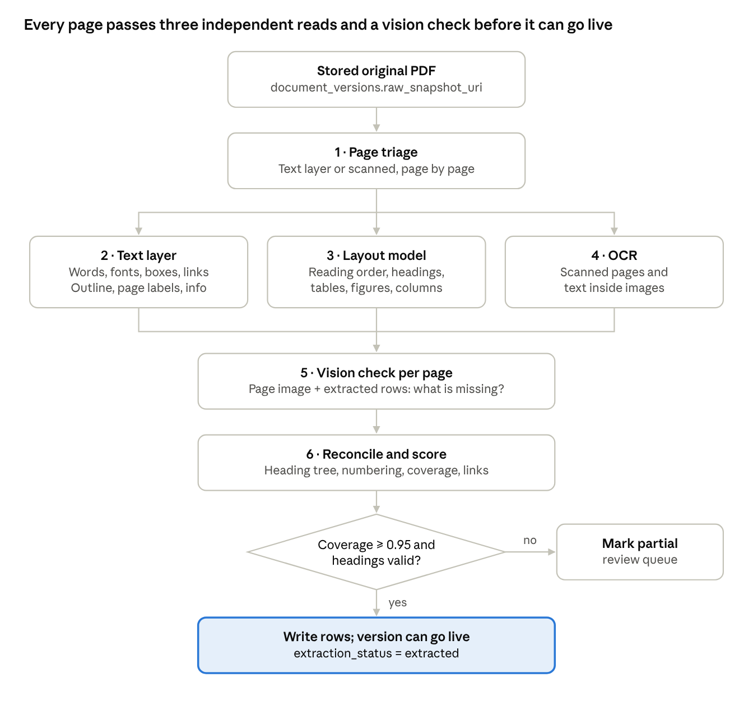
PDF extraction · 6 passes, 1 gate
Pass | What it reads | Tool options | Catches
1. Page triage | Size of the text layer and image area on each page | PyMuPDF | Scanned or mixed pages that need OCR
2. Text layer | Every word with font, size, weight and position; the PDF outline (bookmarks); printed page labels; document info (title, author, created and modified dates); link annotations | PyMuPDF, pdfplumber | All digital text, heading candidates, links, printed page numbers
3. Layout model | Reading order, headings, lists, tables with cell structure, figures, multi-column pages | Docling (layout model + TableFormer), Unstructured hi_res, Google Document AI Layout Parser | Correct order on two-column pages, table cells, figure boxes
4. OCR | Scanned pages and text inside images | Document AI OCR, Tesseract | Text with no text layer, error text in screenshots
5. Vision check | The page image plus the rows extracted so far, sent to a vision model with the question “what on this page is missing or wrong?” | Gemini Flash | Missed callouts, text in diagrams, broken tables; gaps are added as vision_llm rows
6. Reconcile and score | All passes together | Our code | Duplicates merged, heading tree built, coverage scored
Getting headings right. Heading sources are used in order of trust: the PDF outline when the file has one, then numbering patterns (“2.3”, “Issue:”, “Resolution:”, “Error 2:”), then font size and weight against the body text, then the layout model's title class. Disagreements are flagged. The tree is then validated: section numbers run without gaps, every error sits under an issue or resolution heading, and every error has a fix.
The gate. A version goes live only when every page has a row, text coverage is at least 0.95, the heading tree is valid, table cell counts match, every link annotation is captured, and the vision check found nothing missing (or its findings were added). Anything else is marked partial and queued for review.
Regression set. Keep about 20 PDFs whose extraction was checked by hand. Re-run them on every parser or model upgrade (parser_version), and block the upgrade if headings or text coverage get worse.
Why several passes: the CVPR 2025 OmniDocBench study found that pipeline parsers and vision-language models each have strengths that vary by document type (Ouyang et al.), and text-only extraction loses visual information: page-image retrieval scored 81.3 against 67.0 for the best text pipeline on ViDoRe (Faysse et al., 2024). Combining a layout pipeline, OCR and a vision check covers each one's blind spots.

Metadata captured from each source
What | PDF (file share, SharePoint, Drive) | Confluence page | Stored in
Name | File name; title from document info | Page title | documents.file_name, title
Link | File URL | Page web link | documents.source_url
Location | Folder or site | Space, plus parent pages as a breadcrumb | documents.source_container, metadata.breadcrumb
Created by, created | Author in document info, or the file system's or SharePoint's creator | Page author and creation date | documents.author, source_created_at
Last updated by, last updated | Modifier and modified time from the file system or SharePoint | Author and date of the current version | documents.last_modified_by, source_updated_at
Version | Modified time plus content hash; SharePoint version number | Page version number and version message | document_versions.source_version, metadata.version_message
Labels | File tags, if any | Page labels | documents.tags
Owner | Folder or site owner | Page owner | documents.owner_team, metadata.owner
Permissions | Folder or site sharing | Page and space restrictions | documents.acl_groups
Images and attached files | Embedded images | Attachments: images and PDFs | image rows with asset_source_url; attached PDFs become their own documents, linked by metadata.parent_document_id
Links inside the content | Link annotations | Links in the page body | document_contents.links
Printed page numbers | Page labels (e.g. iv, 12) | — | document_contents.page_label
Confluence returns people as account ids; resolve them to display names and store both. The v2 Get page endpoint returns the page id, title, space, parent, author, owner, creation date and current version (number, date, author, message), with labels and version history on request (endpoint reference). It has no separate last-modified field (Atlassian developer forum), so “last updated” is the current version's date. Confirm field names against Atlassian's API reference during the build.

Images and multimodal search
Images become searchable in two ways. Route A ships first; route B is tested as an experiment variant.
Route | How | Finds | Cost
A. Images as text (always) | The caption, description and in-image text join the chunk of the error they illustrate, and are embedded and keyword-indexed with it | A question quoting text from a screenshot, e.g. “File exceeds 25 MB” | One vision-model call per image at ingestion
B. Images as vectors (experiment) | Embed each figure and each page image with gemini-embedding-2, which maps images and text into one space, and search them with the same query vector | Visual content that text misses: diagrams, layouts, charts | One embedding per image and page; more index rows
Why B is worth testing: on the ViDoRe benchmark, retrieving page images directly (ColPali) scored 81.3 nDCG@5, against 67.0 for the best text-extraction pipeline (layout parsing plus captions) and 66.1 with OCR (Faysse et al., 2024). ColPali uses its own multi-vector model, so we confirm the gain with gemini-embedding-2 on our documents before relying on it.
Gemini limits that shape route B (Gemini embeddings guide):
- Images: PNG or JPEG, up to 6 per request; wrap each image in its own content entry to get one embedding per image.
- PDFs: up to 6 pages per request, and Google recommends one page per request for best quality. Each page costs 258 tokens for its image plus its text, within the 8,192-token limit. Longer input is cut off without an error.
- Don't add the task: prefix to multimodal input; Google generally recommends against it.
Storage. Binary files stay in object storage, not in Postgres; tables keep the URI and hash. Layout: gs://rag-raw/{source}/{document_id}/v{n}/original.pdf for originals and gs://rag-assets/{document_id}/v{n}/page-0002.png or img-0002-01.png for renders and crops. Users get signed links, and bucket access mirrors acl_groups.

Completeness checks
- Every page captured: the number of page rows equals document_versions.page_count.
- Coverage: extraction_coverage is the share of each page's text found in its text elements. A version below 0.95 is marked partial for review.
- Scanned pages: pages with almost no native text go through OCR and are counted in ocr_page_count.
- Images: every non-decorative image has a description, or a logged failure in ingestion_events.
- Gate: a version whose extraction failed stays staged and is never switched on.

Table 3: chunks
The retrieval units: the source of truth for what gets embedded. One row per chunk; unique on (document_id, chunker_version, seq).
Column | Type | Purpose
chunk_id | uuid, PK | Internal id
document_id, version_no | FK to document_versions | Which document and version this chunk belongs to (cascade delete)
group_id | text | The answer unit results are grouped by: the FAQ id for FAQs, the document id otherwise
chunk_type | text | question, paraphrase, qa, error_chunk, overview, section, table_row
parent_chunk_id | uuid, FK (self) | Small-to-big link, for example an error chunk to its heading overview
content_ids | uuid[] | Lineage to the exact contents it was built from
seq | int | Order within the document
path_label | text | “How do I upload files? › Upload › Issue resolution › Error 2”
file_name | text | Source file, e.g. faq-12.pdf
page_numbers | int[] | All pages the chunk covers: the union of its contents' pages
section_no | text | Section number of the chunk's heading, e.g. 2.3
heading, issue | text | Structured fields for filters and display
error_code | text | Error tag, e.g. Error 2 or E-102
tags | text[] | Labels from the source (Confluence labels) or assigned at ingestion
source_link | text | Deep link to where the chunk starts
chunk_text | text | Text shown to users and passed to the LLM
embed_text | text | Exact string sent to the embedder, e.g. title: {path_label} | text: {chunk_text}
token_count | int | Size checks
location | jsonb | Non-page positions (Confluence anchor, Excel row)
chunker, chunker_version | text | Strategy that built it, so variants V1–V6 can coexist
content_hash | text | Hash of embed_text; drives re-embedding
is_active | boolean | True only for the version search serves
run_id | bigint, FK | The pipeline run that built it

Table 4: retrieval_index
The only table retrieval reads. One row per chunk per embedding model, with copies of every field a query filters or displays; unique on (chunk_id, embedding_model).
Column | Type | Purpose
index_id | bigint, PK | Internal id
chunk_id | uuid, FK | Back to chunks (cascade delete)
embedding_model | text | e.g. gemini-embedding-2@768
embedding | vector(768) | The vector (halfvec if you move to 3,072 dimensions)
content_hash | text | Lets a new version reuse the stored vector of an unchanged chunk
tsv | tsvector | Full-text index over path label + chunk text
document_id, version_no, group_id, chunk_type | copied | Grouping and filtering without joins
source_system, doc_type, language | copied | Filters
acl_groups | text[], copied | Row-level security
file_name, page_numbers, section_no, error_code, tags | copied | Citations, and filters such as “only Error 2” or “only this PDF”
source_url, source_link | copied | Link to the document and to the exact page or section
path_label, chunk_text, location | copied | Display without joins
chunker_version, is_active | copied | Pick one experiment variant; serve only the active version
run_id, embedded_at | bigint, timestamptz | Which run embedded it, and when
Five audit tables sit beside these four: document_versions, ingestion_runs, ingestion_events, retrieval_logs and retrieval_hits. They are described under Traceability, audit and monitoring below.

Chunk metadata for citations
Every chunk carries its file name, every page it covers, its section number and its error tag, so each answer can say exactly where it came from.
- Page numbers are set by the parser on each element in table 2; a chunk's page_numbers is the union of its elements' pages, so a chunk that crosses a page break lists both pages.
- Tag numbers: section_no is the heading number printed in the PDF (e.g. 2.3); error_code is the error's own tag (e.g. Error 2 or E-102).
- Lineage: content_ids points to the exact elements behind the chunk, for audits and “show me the original”.
What a search hit returns for the Error 2 chunk:
{
"file_name": "faq-12.pdf",
"source_url": "https://files.example.com/faq/faq-12.pdf",
"source_link": "https://files.example.com/faq/faq-12.pdf#page=2",
"version_no": 2,
"page_numbers": [2, 3],
"section_no": "2.3",
"error_code": "Error 2",
"path_label": "How do I upload files? > Upload > Issue resolution > Error 2",
"tags": ["upload"],
"chunk_type": "error_chunk",
"group_id": "FAQ-12",
"run_id": 418
}
Citation shown to the user: faq-12.pdf · pages 2–3 · section 2.3 · Error 2. Sources without pages use location, for example “Leave policy (Confluence) · #annual-leave” or “errors.xlsx · Sheet1 · row 14”.

Ingestion and update flow
Each stage writes one table and checks a hash first, so a re-run touches only what changed.
- Register. A connector per source (PDF folder, Confluence API, Excel files) upserts documents on (source_system, external_id). If content_hash is unchanged, stop here.
- Extract structure. Parse into document_contents in reading order:
  - PDFs: layout-aware parsing into headings, paragraphs, lists and tables, with page numbers. FAQ PDFs also tag issue, resolution and error blocks.
  - Confluence: page storage format (HTML) gives headings and tables directly; keep anchors for links.
  - Excel: one table_row element per row, with the column headers stored alongside the values in raw.
  - Replace a document's contents in one transaction, so a half-parsed version is never visible.
- Chunk. A LangGraph conditional edge picks the strategy from doc_type and the structure found:
  - FAQ, single-page: one qa chunk. FAQ, multi-page: one error_chunk per error plus one overview per heading. Both add question and paraphrase chunks.
  - Other documents: one chunk per heading section, packed to 400–600 tokens; tables are kept as their own chunks; a new heading always starts a new chunk.
  - Excel: one chunk per row written as “Column: value” lines, or small groups of related rows.
  - Every chunk gets its path_label, embed_text and content_hash.
- Embed. Embed only chunks with no retrieval_index row for that content_hash and model. Use the batch API, then insert with the copied metadata.
- Swap versions. Insert the new version's rows, then mark the old version's rows is_active = false (or delete them) in the same transaction.
- Handle deletes. When a source item disappears, set documents.status = 'deleted' and delete its rows. Foreign keys with ON DELETE CASCADE remove its contents, chunks and index rows.
- Log. Record counts and errors in ingestion_runs.
A new chunking strategy reruns from step 3; a new embedding model reruns step 4 only.

Retrieval path
A query hits retrieval_index alone; chunks is read only to widen context for the top few results.
- Embed the query with the same model as the index rows it will search (task: question answering | query: {text} for gemini-embedding-2).
- Filter first: embedding_model, is_active, chunker_version, plus any user filters (source_system, doc_type). Row-level security applies acl_groups automatically.
- Search twice, in parallel: vector top 50 and full-text top 50, both on retrieval_index.
- Fuse and group: Reciprocal Rank Fusion (k = 60), then group by group_id and score each group by its best chunk.
- Expand (optional): for the top 3 groups, pull the parent_chunk_id overview or neighbouring seq chunks from chunks when the LLM needs more context.
- Answer and cite: return path_label, source_link (the exact page or section), file name, page numbers, section number and error tag with every answer, log the question and its hits, then route by confidence: fixed answer, LLM answer from matched chunks, or hand-off.

Design decisions and evidence
Every table boundary and key column maps to a published result or an established tool's design.
Decision | Why | Evidence
Store extracted structure (table 2) separately from chunks (table 3) | Parse once, which is the slow, OCR-heavy step; try many chunkings | Unstructured partitions documents into elements first and chunks second, keeping the source elements on each chunk (orig_elements)
Chunk by document structure, not fixed size | Each chunk covers one topic | On FinanceBench (141 questions), element-based chunking reached 53.19% Q&A accuracy against 48.23% for the best fixed-size setting, using 20,843 chunks instead of 16,046–64,058 (Jimeno Yepes et al., 2024). Fixed 256-token chunks still scored higher on page retrieval (73.05% vs 67.38%), so we confirm on our data
A new heading starts a new chunk; tables stay whole | No chunk mixes two sections or splits a table | Unstructured's by_title strategy closes the chunk at every title and never combines a table with other elements
Small, self-contained chunks | Finer units retrieve better | Proposition-level indexing significantly outperformed passage-level indexing (Chen et al., EMNLP 2024)
path_label embedded with the chunk | Restores context a chunk loses when cut out | Context on chunks cut top-20 retrieval failures 35%, 49% with BM25 and 67% with a reranker (Anthropic, 2024)
Embeddings in their own table (4), keyed by model | Re-embed or compare models without touching chunks | pgai Vectorizer stores embeddings in a separate _store table with a foreign key ON DELETE CASCADE and UNIQUE (id, chunk_seq); pgvector indexes one model's rows with partial indexes
Content hash and source id at every stage | Skip unchanged items; clean up deleted ones | The LangChain indexing API records a hash, write time and source id per document; its example re-run skipped 8 of 10 documents. LlamaIndex re-processes a document only when its hash changes
File, page, position and hierarchy on every element | Every chunk traces to an exact place in the source | Unstructured attaches filename, page_number, bounding-box coordinates, parent_id and last_modified to each element
Deep links with #page=N | A citation opens the PDF at the cited page | The application/pdf media type defines page= as a fragment identifier, first page = 1 (RFC 8118)
parent_chunk_id links | Search small chunks, answer with wider context | LangChain ParentDocumentRetriever indexes small child chunks and keeps parents separately; RAPTOR (ICLR 2024) built a tree of summaries and raised the best QuALITY accuracy by 20 points with GPT-4
Vector and full-text search in the same table, fused with RRF | Exact codes and terms plus meaning | pgvector recommends Postgres full-text search for hybrid search, combined with RRF or a cross-encoder; RRF beat every individual ranking it combined (Cormack et al., SIGIR 2009)
Filter fields copied into table 4 | Filters without joins; correct filtered results | pgvector applies filters after the HNSW scan, so a filter matching 10% of rows can leave about 4 results by default; it recommends iterative scans, partial indexes and partitioning
Access control with row-level security | No query can skip the permission check | Supabase: RLS also filters vector search and “is always applied even as new queries and application logic is introduced”
group_id plus question and paraphrase chunks for FAQs | Match the question and the answer; rank FAQs by best chunk | Sakata et al., SIGIR 2019; Mass et al., ACL 2020

Indexes, access control and scale
Index retrieval_index for the three things every query does (nearest vectors, keyword match, filter by model and permission) and keep the other tables indexed for lineage lookups.
Index | On | Why
HNSW, partial | embedding WHERE embedding_model = 'gemini-embedding-2@768' | One index per model; filtering on model inside the index
GIN | tsv | Full-text search
GIN | acl_groups | Fast permission checks under RLS
B-tree | (group_id), (document_id), (chunk_id) | Grouping, cascades, joins back to chunks
Unique | documents (source_system, external_id), chunks (document_id, chunker_version, seq), retrieval_index (chunk_id, embedding_model) | Idempotent upserts
- pgvector version: use 0.8.x (0.8.7 is current) for iterative index scans. Set hnsw.iterative_scan = relaxed_order so filtered queries still return the full top 50.
- Dimensions: vector(768) indexes directly (HNSW limit 2,000). For 3,072 dimensions, index halfvec(3072) (limit 4,000).
- Access control: enable row-level security on retrieval_index with a policy that allows a row when its acl_groups overlap the user's groups. Copy acl_groups from documents at ingestion, and re-copy whenever a source's permissions change.
- Scale: a 768-dimension float vector is about 3 KB, so 1 million chunks is roughly 3 GB of vectors before the index. Past a few million rows, or with many tenants, list-partition retrieval_index by tenant or source, as pgvector recommends for many distinct filter values.
- Bulk loads: build HNSW indexes after the first bulk load, raise maintenance_work_mem for the build, and VACUUM after large deletes.

Appendix: DDL and retrieval query
Stage 1 tables (documents, document_versions, document_contents) are final; chunks, retrieval_index and the audit tables are finalized in the next steps. Tested on PostgreSQL 16 with pgvector:
- Row-level security returned only rows for the caller's groups, and none for a user with no groups.
- Deleting a document removed its contents, chunks and index rows.
- A staged version stayed invisible until the switch, and an unchanged chunk reused its stored vector.
- The retrieval query returned each hit with its file name, pages, section number and error tag.
- Stage 1 constraints rejected an image row with no stored image, a page row with no page number, and a second page row for the same page.
CREATE EXTENSION IF NOT EXISTS vector;
-- Audit: every pipeline run, with the code and model versions it used
CREATE TABLE ingestion_runs (
run_id bigint GENERATED ALWAYS AS IDENTITY PRIMARY KEY,
source_system text NOT NULL,
pipeline_version text NOT NULL, -- git commit of the ingestion code
parser_version text NOT NULL,
chunker_version text NOT NULL,
embedding_model text NOT NULL,
triggered_by text NOT NULL, -- schedule, webhook, user id
status text NOT NULL DEFAULT 'running'
CHECK (status IN ('running','succeeded','failed','partial')),
started_at timestamptz NOT NULL DEFAULT now(),
finished_at timestamptz,
docs_added int NOT NULL DEFAULT 0,
docs_updated int NOT NULL DEFAULT 0,
docs_skipped int NOT NULL DEFAULT 0,
docs_deleted int NOT NULL DEFAULT 0,
docs_failed int NOT NULL DEFAULT 0,
chunks_embedded int NOT NULL DEFAULT 0,
chunks_reused int NOT NULL DEFAULT 0
);
-- 1. Source registry: one row per source item (file, page, sheet) [FINAL]
CREATE TABLE documents (
document_id uuid PRIMARY KEY DEFAULT gen_random_uuid(),
source_system text NOT NULL, -- pdf, confluence, excel, sharepoint, web
external_id text NOT NULL, -- file id/path, Confluence page id, workbook+sheet
source_uri text, -- machine location: gs://..., API path
source_url text NOT NULL, -- clickable link to the file or page
source_container text, -- Confluence space, SharePoint site, folder
file_name text NOT NULL, -- shown in every citation
title text,
mime_type text NOT NULL, -- application/pdf, text/html, ...sheet
doc_type text NOT NULL DEFAULT 'reference', -- faq, policy, runbook, reference
tags text[] NOT NULL DEFAULT '{}', -- Confluence labels, file tags
author text,
last_modified_by text,
owner_team text, -- who answers questions about the content
language text NOT NULL DEFAULT 'english',
acl_groups text[] NOT NULL DEFAULT '{}',
metadata jsonb NOT NULL DEFAULT '{}', -- any other source fields
current_version int, -- version search serves; NULL until first activation
content_hash text NOT NULL, -- hash of the latest source content
status text NOT NULL DEFAULT 'active' CHECK (status IN ('active','deleted')),
source_created_at timestamptz,
source_updated_at timestamptz,
first_ingested_at timestamptz NOT NULL DEFAULT now(),
last_ingested_at timestamptz,
last_run_id bigint REFERENCES ingestion_runs,
UNIQUE (source_system, external_id)
);
-- 1a. Every version ever ingested, with a stored copy of the original [FINAL]
CREATE TABLE document_versions (
document_id uuid NOT NULL REFERENCES documents ON DELETE CASCADE,
version_no int NOT NULL,
source_version text, -- Confluence version number, file modified time
content_hash text NOT NULL,
raw_snapshot_uri text NOT NULL, -- gs://rag-raw/... copy of the original file or page export
source_url text NOT NULL, -- link as it was for this version
mime_type text NOT NULL,
file_size_bytes bigint,
page_count int,
image_count int NOT NULL DEFAULT 0,
ocr_page_count int NOT NULL DEFAULT 0, -- pages that needed OCR (scanned)
extraction_status text NOT NULL DEFAULT 'pending'
CHECK (extraction_status IN ('pending','extracted','partial','failed')),
extraction_coverage numeric(5,4), -- share of page text captured in elements, 0-1
status text NOT NULL DEFAULT 'staged'
CHECK (status IN ('staged','active','superseded','purged')),
run_id bigint NOT NULL REFERENCES ingestion_runs,
ingested_at timestamptz NOT NULL DEFAULT now(),
activated_at timestamptz,
superseded_at timestamptz,
PRIMARY KEY (document_id, version_no)
);
-- 2. Everything extracted: one row per page, text element and image [FINAL]
CREATE TABLE document_contents (
content_id uuid PRIMARY KEY DEFAULT gen_random_uuid(),
document_id uuid NOT NULL,
version_no int NOT NULL,
parent_content_id uuid REFERENCES document_contents ON DELETE CASCADE,
seq int NOT NULL, -- reading order within the version
element_type text NOT NULL CHECK (element_type IN (
'page','heading','issue','resolution','error','paragraph','list',
'table','table_row','image','faq_question','faq_answer','other')),
level int, -- heading depth
heading_path text[] NOT NULL DEFAULT '{}',
section_no text, -- number printed on the heading, e.g. 2.3
page_no int, -- page the element starts on
page_numbers int[] NOT NULL DEFAULT '{}', -- every page it appears on
page_label text, -- page number as printed, e.g. iv or 12 (may differ from page_no)
text text NOT NULL DEFAULT '', -- page: full page text; image: caption
raw jsonb, -- original markup or table cells with headers
coordinates jsonb, -- bounding box on the page
location jsonb NOT NULL DEFAULT '{}', -- Confluence anchor, Excel sheet and row
source_link text, -- deep link: file.pdf#page=2, page URL#anchor
links jsonb NOT NULL DEFAULT '[]', -- links inside the element: [{url, text}]
asset_uri text, -- stored image: page render or cropped figure
asset_source_url text, -- original image URL, e.g. Confluence attachment
asset_mime text, -- image/png, image/jpeg
asset_hash text, -- detects repeated logos and unchanged images
width_px int,
height_px int,
ocr_text text, -- text read from a scanned page or inside an image
ocr_confidence real,
caption text, -- caption printed in the document
image_description text, -- vision-model description, labelled as generated
description_model text, -- model and version that wrote the description
extraction_method text NOT NULL CHECK (extraction_method IN ('native','ocr','vision_llm','api')),
content_hash text NOT NULL,
parser text NOT NULL,
parser_version text NOT NULL,
run_id bigint NOT NULL REFERENCES ingestion_runs,
UNIQUE (document_id, version_no, seq),
FOREIGN KEY (document_id, version_no) REFERENCES document_versions ON DELETE CASCADE,
CHECK (element_type NOT IN ('page','image') OR asset_uri IS NOT NULL),
CHECK (element_type <> 'page' OR page_no IS NOT NULL)
);
CREATE UNIQUE INDEX dc_one_page_row ON document_contents (document_id, version_no, page_no)
WHERE element_type = 'page';
CREATE INDEX dc_asset_hash ON document_contents (asset_hash) WHERE asset_hash IS NOT NULL;
-- 3. Retrieval units [NEXT TO FINALIZE]
CREATE TABLE chunks (
chunk_id uuid PRIMARY KEY DEFAULT gen_random_uuid(),
document_id uuid NOT NULL,
version_no int NOT NULL,
group_id text NOT NULL,
chunk_type text NOT NULL
CHECK (chunk_type IN ('question','paraphrase','qa','error_chunk',
'overview','section','table_row')),
parent_chunk_id uuid REFERENCES chunks ON DELETE SET NULL,
content_ids uuid[] NOT NULL DEFAULT '{}',
seq int NOT NULL,
path_label text NOT NULL,
file_name text NOT NULL,
page_numbers int[] NOT NULL DEFAULT '{}',
section_no text,
heading text,
issue text,
error_code text,
tags text[] NOT NULL DEFAULT '{}',
source_link text NOT NULL,
chunk_text text NOT NULL,
embed_text text NOT NULL,
token_count int,
location jsonb NOT NULL DEFAULT '{}',
chunker text NOT NULL,
chunker_version text NOT NULL,
content_hash text NOT NULL,
is_active boolean NOT NULL DEFAULT false,
run_id bigint NOT NULL REFERENCES ingestion_runs,
created_at timestamptz NOT NULL DEFAULT now(),
UNIQUE (document_id, version_no, chunker_version, seq),
FOREIGN KEY (document_id, version_no) REFERENCES document_versions ON DELETE CASCADE
);
-- 4. The only table retrieval reads [TO REVIEW]
CREATE TABLE retrieval_index (
index_id bigint GENERATED ALWAYS AS IDENTITY PRIMARY KEY,
chunk_id uuid NOT NULL REFERENCES chunks ON DELETE CASCADE,
embedding_model text NOT NULL,
embedding vector(768) NOT NULL,
content_hash text NOT NULL,
document_id uuid NOT NULL,
version_no int NOT NULL,
group_id text NOT NULL,
chunk_type text NOT NULL,
source_system text NOT NULL,
doc_type text NOT NULL,
language text NOT NULL,
acl_groups text[] NOT NULL DEFAULT '{}',
path_label text NOT NULL,
chunk_text text NOT NULL,
file_name text NOT NULL,
source_url text NOT NULL,
source_link text NOT NULL,
page_numbers int[] NOT NULL DEFAULT '{}',
section_no text,
error_code text,
tags text[] NOT NULL DEFAULT '{}',
location jsonb NOT NULL DEFAULT '{}',
chunker_version text NOT NULL,
is_active boolean NOT NULL DEFAULT false,
run_id bigint NOT NULL REFERENCES ingestion_runs,
tsv tsvector GENERATED ALWAYS AS (
setweight(to_tsvector('english', path_label), 'A') ||
setweight(to_tsvector('english', chunk_text), 'B')) STORED,
embedded_at timestamptz NOT NULL DEFAULT now(),
UNIQUE (chunk_id, embedding_model)
);
-- Audit: what happened to each document in each run [TO REVIEW]
CREATE TABLE ingestion_events (
event_id bigint GENERATED ALWAYS AS IDENTITY PRIMARY KEY,
run_id bigint NOT NULL REFERENCES ingestion_runs,
document_id uuid, -- kept even if the document is later deleted
external_id text NOT NULL,
version_no int,
action text NOT NULL
CHECK (action IN ('added','updated','skipped','deleted','failed','acl_changed')),
reason text, -- e.g. 'hash unchanged', parser error message
chunks_embedded int NOT NULL DEFAULT 0,
chunks_reused int NOT NULL DEFAULT 0,
at timestamptz NOT NULL DEFAULT now()
);
-- Audit: every question, and exactly what was retrieved and shown [TO REVIEW]
CREATE TABLE retrieval_logs (
log_id bigint GENERATED ALWAYS AS IDENTITY PRIMARY KEY,
asked_at timestamptz NOT NULL DEFAULT now(),
user_id text NOT NULL,
user_groups text[] NOT NULL,
session_id text,
query_text text NOT NULL,
embedding_model text NOT NULL,
chunker_version text NOT NULL,
filters jsonb NOT NULL DEFAULT '{}',
route text NOT NULL CHECK (route IN ('fixed_answer','llm_answer','handoff')),
top_score float8,
answer_text text,
llm_model text,
prompt_version text,
latency_ms int,
feedback smallint, -- 1 helpful, -1 not helpful
feedback_comment text
);
CREATE TABLE retrieval_hits (
log_id bigint NOT NULL REFERENCES retrieval_logs ON DELETE CASCADE,
rank int NOT NULL,
index_id bigint, -- no FK: index rows may be purged later
chunk_id uuid NOT NULL,
document_id uuid NOT NULL,
version_no int NOT NULL,
content_hash text NOT NULL,
rrf_score float8 NOT NULL,
cosine float8,
used_in_answer boolean NOT NULL DEFAULT false,
file_name text NOT NULL, -- snapshot, so the citation survives purges
page_numbers int[] NOT NULL,
section_no text,
error_code text,
source_link text NOT NULL,
PRIMARY KEY (log_id, rank)
);
CREATE INDEX ri_hnsw_gemini2_768 ON retrieval_index
USING hnsw (embedding vector_cosine_ops)
WHERE embedding_model = 'gemini-embedding-2@768';
CREATE INDEX ri_tsv ON retrieval_index USING gin (tsv);
CREATE INDEX ri_acl ON retrieval_index USING gin (acl_groups);
CREATE INDEX ri_group ON retrieval_index (group_id);
CREATE INDEX ri_document ON retrieval_index (document_id, version_no);
CREATE INDEX ri_chunk ON retrieval_index (chunk_id);
CREATE INDEX ri_reuse ON retrieval_index (embedding_model, content_hash);
CREATE INDEX ri_error ON retrieval_index (error_code);
CREATE INDEX dc_version ON document_contents (document_id, version_no);
CREATE INDEX ch_version ON chunks (document_id, version_no);
CREATE INDEX ch_parent ON chunks (parent_chunk_id);
CREATE INDEX ie_run ON ingestion_events (run_id);
CREATE INDEX ie_document ON ingestion_events (document_id, at);
CREATE INDEX rl_asked ON retrieval_logs (asked_at);
CREATE INDEX rh_chunk ON retrieval_hits (chunk_id);
CREATE INDEX rh_document ON retrieval_hits (document_id, version_no);
ALTER TABLE retrieval_index ENABLE ROW LEVEL SECURITY;
CREATE POLICY ri_read ON retrieval_index FOR SELECT
USING (acl_groups && string_to_array(current_setting('app.user_groups', true), ','));
The retrieval query runs on retrieval_index only. Before it, the app sets the caller's groups with SELECT set_config('app.user_groups', 'support,hr', false). $1 is the query vector, $2 the query text and $3 the model name.
WITH vec AS (
SELECT index_id, group_id, cos, row_number() OVER (ORDER BY cos DESC) AS rnk
FROM (SELECT index_id, group_id, 1 - (embedding <=> $1::vector) AS cos
FROM retrieval_index
WHERE embedding_model = $3 AND is_active
ORDER BY embedding <=> $1::vector
LIMIT 50) v
),
qry AS (
SELECT replace(plainto_tsquery('english', $2)::text, '&', '|')::tsquery AS q
),
fts AS (
SELECT index_id, group_id, row_number() OVER (ORDER BY r DESC) AS rnk
FROM (SELECT ri.index_id, ri.group_id, ts_rank_cd(ri.tsv, qry.q) AS r
FROM retrieval_index ri, qry
WHERE ri.embedding_model = $3 AND ri.is_active AND ri.tsv @@ qry.q
ORDER BY r DESC
LIMIT 50) f
),
fused AS (
SELECT index_id, group_id, sum(1.0 / (60 + rnk)) AS rrf, max(cos) AS cos
FROM (SELECT index_id, group_id, rnk, cos FROM vec
UNION ALL
SELECT index_id, group_id, rnk, NULL::float8 FROM fts) u
GROUP BY index_id, group_id
),
ranked AS (
SELECT f.rrf, f.cos, ri.*,
row_number() OVER (PARTITION BY f.group_id ORDER BY f.rrf DESC) AS pos
FROM fused f JOIN retrieval_index ri USING (index_id)
)
SELECT group_id,
rrf AS score, -- best chunk's score (MaxP)
cos AS best_cosine, -- NULL if the chunk matched on keywords only
path_label, chunk_text,
file_name, page_numbers, section_no, error_code,
source_url, source_link, version_no
FROM ranked
WHERE pos = 1
ORDER BY score DESC
LIMIT 10;
- Superusers and the table owner bypass row-level security, so the application must connect as a separate role that has only SELECT.
- The final join is on the same table's primary key for at most 100 rows; it fetches display text without touching chunks.
Trace any logged answer back to its source ($1 is the log_id). After an old version is purged, the citation snapshot, version, stored original and source link still come back; only the chunk and element details are empty.
SELECT h.rank, h.used_in_answer,
h.file_name, h.page_numbers, h.section_no, h.error_code, h.source_link,
v.version_no, v.source_version, v.status AS version_status,
v.raw_snapshot_uri, v.run_id,
d.source_url, d.source_container, d.tags, d.author,
c.path_label,
el.elements
FROM retrieval_hits h
JOIN document_versions v USING (document_id, version_no)
JOIN documents d USING (document_id)
LEFT JOIN chunks c USING (chunk_id)
LEFT JOIN LATERAL (
SELECT jsonb_agg(jsonb_build_object('seq', dc.seq, 'pages', dc.page_numbers,
'link', dc.source_link, 'bbox', dc.coordinates)
ORDER BY dc.seq) AS elements
FROM document_contents dc
WHERE dc.content_id = ANY (c.content_ids)
) el ON true
WHERE h.log_id = $1
ORDER BY h.rank;

References
Research papers
- Jimeno Yepes, You, Milczek, Laverde & Li. Financial Report Chunking for Effective Retrieval Augmented Generation. arXiv, 2024.
- Chen et al. Dense X Retrieval: What Retrieval Granularity Should We Use? EMNLP 2024.
- Sarthi, Abdullah, Tuli, Khanna, Goldie & Manning. RAPTOR: Recursive Abstractive Processing for Tree-Organized Retrieval. ICLR 2024.
- Cormack, Clarke & Büttcher. Reciprocal Rank Fusion Outperforms Condorcet and Individual Rank Learning Methods. SIGIR 2009.
- Sakata, Shibata, Tanaka & Kurohashi. FAQ Retrieval using Query-Question Similarity and BERT-Based Query-Answer Relevance. SIGIR 2019.
- Mass, Carmeli, Roitman & Konopnicki. Unsupervised FAQ Retrieval with Question Generation and BERT. ACL 2020.
- Faysse et al. ColPali: Efficient Document Retrieval with Vision Language Models. arXiv, 2024.
Industry practice
- Anthropic. Introducing Contextual Retrieval. 2024.
- Unstructured. Chunking: elements first, by_title sections, isolated tables.
- Unstructured. Document elements and metadata: filename, page number, coordinates, parent id per element.
- Google. Gemini API embeddings guide: gemini-embedding-2 multimodal input, task prefixes, image and PDF limits.
- Timescale / Tiger Data. pgai Vectorizer overview: embeddings in a separate store table.
- LangChain. Syncing data sources to vector stores (indexing API, record manager) and ParentDocumentRetriever.
- LlamaIndex. Ingestion pipeline: document management by doc_id and hash.
- pgvector README: filtering, iterative scans, partial indexes, halfvec, hybrid search, partitioning.
- Supabase. RAG with permissions: row-level security on chunk tables.
- IETF. RFC 8118: The application/pdf Media Type: #page= fragment identifiers.

